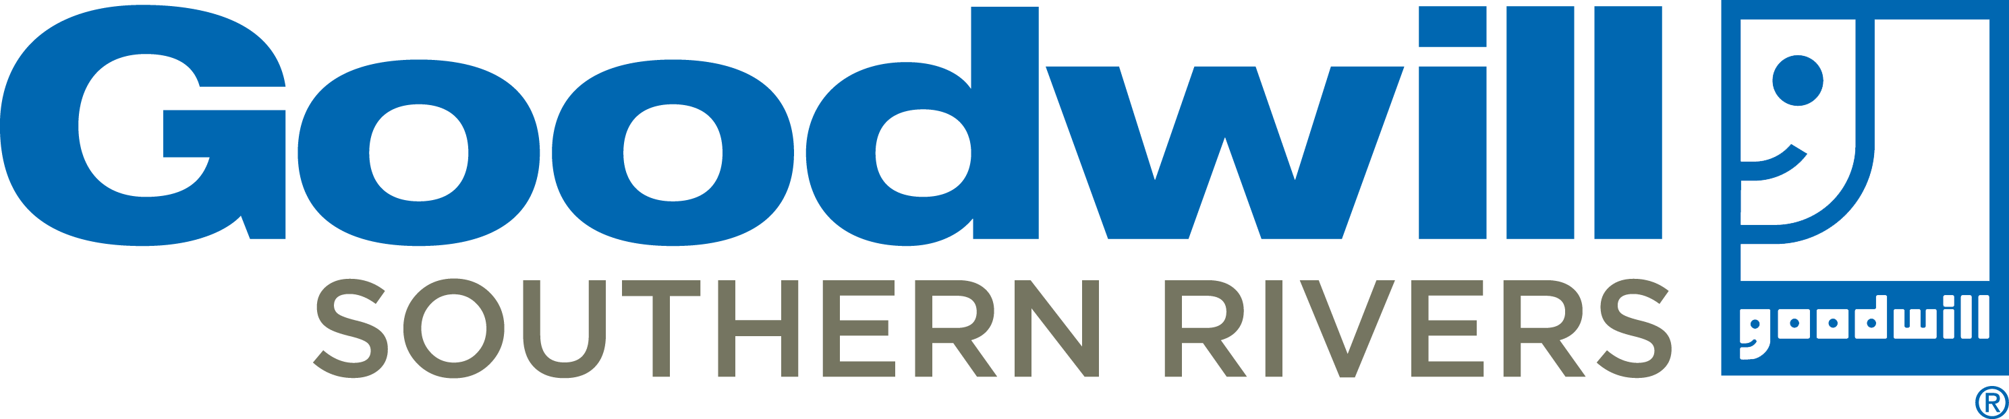
May 2024
Newnan Career Center
228 Bullsboro Dr. | Newnan, GA | 30263
www.goodwillsr.org 770-834-3981
Monday – Thursday 9:00 a.m. – 6:00 p.m.
Friday 9:00 a.m. – 3:00 p.m.

Mon | Tue | Wed | Thu | Fri

 | 3:00 pm LOOK ON THE BACK!  Information about VITA, Training and Center Expectations | Retail Store Hiring Event  10 AM – 1PM  3:00 pm – Ace the Interview  4:00 pm Time Management | 2  10:15 am – Ace the Interview  3:00 pm – Finding you Job  4:00 pm Workplace Expectations | 3  Resume Critique  10AM
6  10:15 am – Ace the Interview  3:00 pm – Finding Your Job  4:00 pm – Resume Lab | 7  10:15 am – Finding Your Job  3:00 pm – Ace the Interview  4:00 pm – Resume + Social Media/Tech Check | 8  Multi-Employer Hiring Event  10 AM – 1PM  3:00 pm – Ace the Interview  4:00 pm Time Management | 9  Potential Hiring Event  10:15 am – Ace the Interview  3:00 pm – Finding you Job  4:00 pm Workplace Expectations | 10  Resume Critique  10AM
13  10:15 am – Ace the Interview  3:00 pm – Finding Your Job  4:00 pm – Resume Lab | 14  10:15 am – Finding Your Job  3:00 pm – Ace the Interview  4:00 pm – Resume + Social Media/Tech Check | 15  10:15 am – Finding Your Job  3:00 pm – Ace the Interview  4:00 pm Time Management | 16  10:15 am – Ace the Interview  3:00 pm – Finding you Job  :00 pm Workplace Expectations | 17  Resume Critique  10AM
20  10:15 am – Ace the Interview  3:00 pm – Finding Your Job  4:00 pm – Resume Lab | 21  10:15 am – Finding Your Job  3:00 pm – Ace the Interview  4:00 pm – Resume + Social Media/Tech Check | 22  10:15 am – Finding Your Job  3:00 pm – Ace the Interview  4:00 pm Time Management | 23  10:15 am – Ace the Interview  3:00 pm – Finding you Job  4:00 pm Workplace Expectations | 24  Resume Critique  10AM
27  CLOSED  Celebrate Memorial Day | 28  10:15 am – Finding Your Job  3:00 pm – Ace the Interview  4:00 pm – Resume + Social Media/Tech Check | 29  10:15 am – Finding Your Job  3:00 pm – Ace the Interview  4:00 pm Time Management | 30  10:15 am – Ace the Interview  3:00 pm – Finding you Job  :00 pm Workplace Expectations | 31

THINGS YOU NEED TO KNOW | ASK A CAREER CENTER SPECIALIST
- All clients are required to complete orientation once a year. This gives an overview of all the services available to you.  - Check in is required each day you come to the center.  - You could meet your next employer any day of the week; because of that, please think about this when choosing your outfit. Full dress code policy is available.  - You will hear from us to check in on your job search. We are always interested in celebrating your success! | - Ask about Career Coaching in Albany, Carrollton and Newnan  - Ask about Goodwill Training Academy  - Ask about Goodwill Workshops and Career Exploration  - Ask about Northstar Computer Skills classes  - Ask about GED and ESL classes  - Ask about Veteran Services  - Ask about Financial and free tax (VITA) Services  - Ask about Youth Programs
WHY should I enroll in the Goodwill Workshop Series?
Let us help you Get the Job and Keep the Job!

Everyone that completes the Getting the Job Series:
- Goodwill Gift Card
- Priority Job Search Support, including referrals to employers
- Mock Interviews by appointment
- One on One Resume Review
- Access to additional Skills 2 Succeed Workshops

Free Tax assistance available to all who have  household income at $64,000 or less.  Click here to make an appointment:  www.goodwillsr.org/vita |  | Want to work for Goodwill?  Click here to learn more about  open positions:  www.goodwillsr.org/careers
Visit your local Career Center for  weekly updates to the Hot Job Board!  For a location near you, click here:  https://www.goodwillsr.org/career-centers |  | Learn more about Goodwill Training Academy!  Click here to see what is offered: www.goodwillsr.org/certification-courses
To see calendars from other Career Centers  in our territory, click here:  www.goodwillsr.org/events |  | Looking for a Retail store near you?  www.goodwillsr.org/retail-stores
We want to celebrate YOU!
Tell us about your Job: https://forms.office.com/r/8rNqn8LRMY

